Functions and its Graphs

Introduction: Mathematical Rules that Shape Our World
People encounter different types of functions every day without even realizing it. When a tricycle driver charges you ₱10 for the first 3 kilometers and ₱2 for each additional kilometer, that is a piecewise function. When you throw a ball upward and watch it trace a curved path, that is a quadratic function. When you calculate how much water a cube-shaped tank can hold, that is a cubic function. When you find the side length of a square given its area, that is a square root function.

Functions are mathematical rules that connect an input to an output. Different situations require different types of functions. This reading material examines five important types of functions: linear, quadratic, cubic, square root, cube root, and piecewise functions. Their equations, graphs, properties, and real-life applications will be explored.

Part 1: Linear Functions

Definition and General Form
A linear function is a function whose graph is a straight line. Its general form is:
f(x)=mx+b
Where:
- m is the slope (rate of change) of the line
- b is the y-intercept of the line (the point where the line crosses the y-axis)

Key Properties
Property | Description
Domain | All real numbers (−∞,∞)(−∞,∞)
Range | All real numbers (−∞,∞)(−∞,∞)
Graph Shape | Straight line
Rate of Change | Constant (the slope m)
Intercepts | One x-intercept and one y-intercept

Slope and Its Meaning
The slope m tells us how steep the line is:
Slope | Direction
Positive (m>0) | Line rises from left to right
Negative (m<0) | Line falls from left to right
Zero (m=0) | Horizontal line
Undefined | Vertical line

Example: Graphing a Linear Function
Problem: Graph f(x)=2x+1
Step 1: Identify slope and y-intercept
- Slope m=2
- Y-intercept b=1 → point (0,1)
Step 2: Use slope to find another point
- From (0,1)(0,1), move up 2 units and right 1 unit → (1,3)(1,3)
Step 3: Draw the line through both points

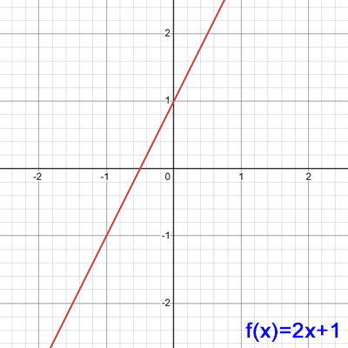

Real-Life Applications of Linear Functions
Scenario | Linear Function | Meaning
Tricycle fare (base fare + per km) | f(x)=10+5x | ₱10 base + ₱5 per km
Electricity bill (fixed fee + per kWh) | B(k)=300+10k | ₱300 fixed + ₱10 per kWh
Mobile data load (₱3 per minute) | B(t)=100−3t | Balance decreases by ₱3/min

Part 2: Quadratic Functions

Definition and General Form
A quadratic function is a function whose graph is a parabola (a U-shaped curve). Its general form is:
f(x)=ax²+bx+c
Where a≠0. The value of a determines the direction and width of the parabola.

Key Properties
Property | Description
Domain | All real numbers (−∞,∞)(−∞,∞)
Range | Depends on vertex ( y≥k or y≤k )
Graph Shape | Parabola (U-shaped)
Rate of Change | Not constant; changes at every point
Vertex | Highest or lowest point
Axis of Symmetry | Vertical line through the vertex: x=−b/2a​

Direction and Width
Value of a | Direction | Width
a>0 | Opens upward (vertex is minimum) | Larger a: narrower  Smaller a: wider
a<0 | Opens downward (vertex is maximum)

Vertex Form
Quadratic functions can also be written in vertex form:
f(x)=a(x−h)²+k
Where (h,k) is the vertex.

Example: Graphing a Quadratic Function
Problem: Graph f(x)=x²−4x+3
Step 1: Find the vertex
- a=1, b=−4

- x=−b​ /2a​=2

- f(2)=(2)²−4(2)+3=−1

- Vertex: (2,−1)(2,−1)
Step 2: Find y-intercept (set x=0)
- f(0)=3 → point (0,3)
Step 3: Find x-intercepts (solve x²−4x+3=0)
- (x−1)(x−3)=0 → x=1 and x=3
Step 4: Plot points and draw the parabola
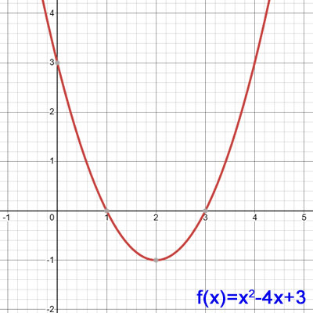

Real-Life Applications of Quadratic Functions
Scenario | Quadratic Function | Meaning
Projectile motion | h(t)=−4.9t²+20t+1.5 | Height of a thrown ball over time
Revenue optimization | R(x)=−12x²+4800 | Profit based on price changes
Maximizing area | A(x)=−2x²+30x | Garden area with fixed fencing

Part 3: Cubic Functions

Definition and General Form
A cubic function is a function where the highest power of x is 3. The simplest form is:
f(x)=x³
The general form is f(x)=ax³+bx²+cx+d where a ≠0.

Key Properties
Property | Description
Domain | All real numbers (−∞,∞)(−∞,∞)
Range | All real numbers (−∞,∞)(−∞,∞)
Graph Shape | S-shaped curve
Intercepts | Passes through the origin (0,0)(0,0)
Symmetry | Odd function: f(−x)=−f(x) (symmetric about the origin)
End Behavior | As x→∞, y→∞; as x→−∞, y→−∞

Table of Values for y=x³
x | -2 | -1 | 0 | 1 | 2
y | -8 | -1 | 0 | 1 | 8

Transformations of Cubic Functions
Transformation | Example | Effect
Vertical shift | f(x)=x³+2 | Moves graph up 2 units
Horizontal shift | f(x)=(x−3)³ | Moves graph right 3 units
Reflection across x-axis | f(x)=−x³ | Flips graph upside down
Vertical stretch | f(x)=2x³ | Makes graph steeper
Vertical compression | f(x)=1/2 x³ | Makes graph flatter

Real-Life Applications of Cubic Functions
Scenario | Cubic Function | Meaning
Volume of a cube | V(s)=s³ | Volume as a function of  side length

Packaging design | V(x)=x(10−2x)(8−2x) | Volume of a box from  folded cardboard
Population growth (some models) | P(t)=at³+bt²+ct+d | Certain growth patterns
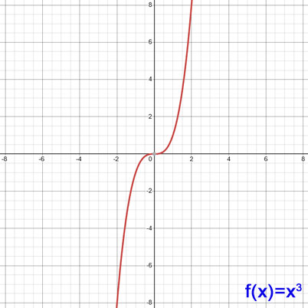

Part 4: Square Root Functions

Definition and General Form
A square root function involves the square root of the input variable. The simplest form is:

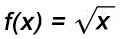
This can also be written in exponential form as f(x) = x^{1/2}.

Key Properties
Property | Description
Domain | x≥0x≥0 (non-negative real numbers)
Range | y≥0y≥0 (non-negative real numbers)
Graph Shape | Curves upward from the origin
Intercepts | Passes through the origin (0,0)(0,0)
Symmetry | Neither even nor odd
End Behavior | As x→∞, y→∞ (increases slowly)

Table of Values for y = x^{1/2}
x | 0 | 1 | 4 | 9 | 16
y | 0 | 1 | 2 | 3 | 4

Transformations of Square Root Functions
General form: f(x)=a(b(x−h))^{1/2}​)+k
Transformation | Example | Effect
Vertical shift | f(x)=$√$x​+3 | Moves graph up 3 units
Horizontal shift | f(x)=$√($x−2)​ | Moves graph right 2 units
Reflection across x-axis | f(x)= −$√$x​ | Flips graph upside down
Vertical stretch | f(x)=2$√$x​ | Makes graph taller
Reflection across y-axis | f(x)=$√$−x​ | Domain changes to x≤0

Real-Life Applications of Square Root Functions
Scenario | Square Root Function | Meaning
Side length from area | s=$√$A​ | Find side of square given area
Pendulum period | T=2π$√(L/g)$​​) | Time period of pendulum depends  on square root of length
Speed from kinetic energy | v=$√$ (2KE / m) | Speed related to square root  of energy
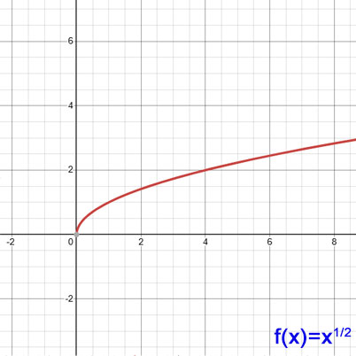

Part 5: Cube Root Functions

Definition and General Form
A cube root function involves the cube root of the input variable. The simplest form is:
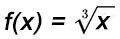
This can also be written in exponential form as f(x) = x^{1/3}.

Key Properties
Property | Description
Domain | All real numbers (−∞,∞)(−∞,∞)
Range | All real numbers (−∞,∞)(−∞,∞)
Graph Shape | S-shaped curve (similar to cubic but rotated)
Intercepts | Passes through the origin (0,0)(0,0)
Symmetry | Odd function: f(−x)=−f(x)f(−x)=−f(x) (symmetric about the origin)
End Behavior | As x→∞, y→∞; as x→−∞, y→−∞

Table of Values for y=x​^{1/3}
x | -8 | -1 | 0 | 1 | 8
y | -2 | -1 | 0 | 1 | 2

Transformations of Cube Root Functions
General form: f(x)=a(b(x−h))^{1/3}​+k
Transformation | Example | Effect
Vertical shift | f(x)= $∛$x​+2 | Moves graph up 2 units
Horizontal shift | f(x)= $∛$(x −3​) | Moves graph right 3 units
Reflection across x-axis | f(x)= − $∛$x​ | Flips graph upside down
Vertical stretch | f(x)=3 $∛$x​ | Makes graph steeper
Reflection across y-axis | f(x)= $∛$ (-x)​ | Reflects horizontally

Real-Life Applications of Cube Root Functions
Scenario | Cube Root Function | Meaning
Side length from volume | s= $∛$V​ | Find cube side given volume
Radius from sphere volume | r= $∛$ (3V/4π)​​ | Find radius given volume
Dilution calculations | c=$∛$(m​​/V) | Concentration in some models
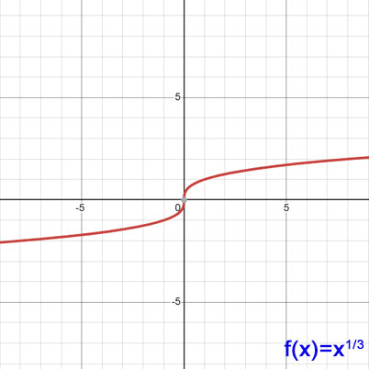

Part 6: Piecewise Functions

Definition
A piecewise function is a function that uses different formulas (or "pieces") for different intervals of the input variable. Instead of one rule for all inputs, it has multiple rules depending on the value of x. The absolute value function is a simple example of a piecewise function.

The Absolute Value Function
The absolute value of a number is its distance from zero on the number line. It is always non-negative.
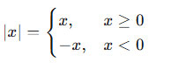

The graph is V-shaped with the vertex at the origin (0,0)(0,0). The left side is a line with slope −1−1, and the right side is a line with slope 11.
Key Insight: Any absolute value function can be rewritten as a piecewise function with two pieces — one for when the expression inside is negative, and one for when it is non-negative.
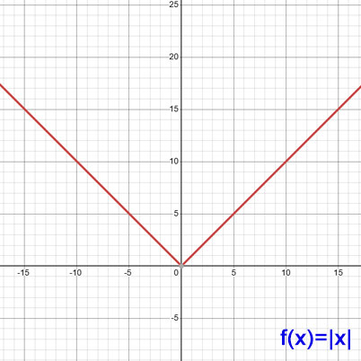

Evaluating Piecewise Functions
To evaluate a piecewise function, determine which condition the input satisfies, then use the corresponding formula.
Example 1: Taxi Fare – ₱35 for first 1.5 km, ₱8 per km for next 10.5 km, ₱20 per km beyond 12 km.
f(d) =
35, when 0 < d ≤ 1.5
35 + 8(d - 1.5), when 1.5 < d ≤ 12
119 + 20(d - 12), when d > 12
- d = 1.2 km → f(1.2) = 35 pesos
- d = 5 km → f(5) = 35 + 8(3.5) = 63 pesos
- d = 15 km → f(15) = 119 + 20(3) = 179 pesos
Example 2: Overtime Pay – ₱80/hour for up to 6 hours, ₱100/hour beyond 6 hours.
f(h) =
80h, when 0 ≤ h ≤ 6
480 + 100(h - 6), when h > 6
- h = 4 hours → f(4) = 320 pesos
- h = 8 hours → f(8) = 480 + 200 = 680 pesos

Graphing Piecewise Functions
To graph a piecewise function:
- Graph each piece on its specified interval
- Use an open circle (○) to indicate an endpoint is not included
- Use a closed circle (●) to indicate an endpoint is included
- Check for continuity or jumps at the breakpoints
Example: Graph of f(x)
f(x) =
x + 1, when x < 3
(x - 4)² + 1, when x ≥ 3
At x = 3:
- Left side: f(3⁻) = 3 + 1 = 4
- Right side: f(3) = (3 - 4)² + 1 = 2
Since 4 ≠ 2, the graph has a jump discontinuity at x = 3.

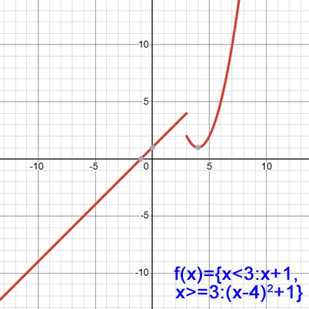

Real-Life Applications of Piecewise Functions
Scenario | Breakpoints | Rule
Taxi Fare | 1.5 km, 12 km | Flat ₱35, then ₱8/km, then ₱20/km
Parking Fee | 1 hour, 5 hours | ₱100 first hour, ₱75/additional hour up  to 5 hrs, flat ₱500 beyond
Water Bill | 10 m³, 30 m³ | ₱20/m³, then ₱30/m³, then ₱50/m³
Internet Data | 3 GB, 7 GB | Free, then ₱50/GB, then ₱70/GB
Bulk Discount | 40 pieces | ₱15/piece, flat ₱550 for 40, then ₱550  + ₱10/excess
Community Tax | ₱100,000, ₱200,000 | ₱0, then 2% over ₱100k, then 7%  over ₱200k

Writing Piecewise Functions from Word Problems
Step 1: Identify the different intervals based on the input variable.
Step 2: Determine the formula or rule for each interval.
Step 3: Write the function using piecewise notation.
Step 4: Test with sample values to verify correctness.
Example: Parking Fee – ₱100 for first hour, ₱75 for each additional hour up to 5 hours, flat ₱500 for more than 5 hours.
f(t) = 100 for 0 < t ≤ 1, f(t) = 100 + 75(t - 1) for 1 < t ≤ 5, and f(t) = 500 for t > 5
or
f(t)=100, 0<t≤1; 100+75(t−1), 1<t≤5; 500, t>5

Key Terms
Term | Definition
Linear Function | A function whose graph is a straight line; general form  f(x)=mx+b, where mm is the slope and b is the y-intercept
Slope | The rate of change of a linear function; represents steepness and direction (positive = rising, negative = falling, zero = horizontal, undefined = vertical)
y-intercept | The point where the graph crosses the y-axis; found by evaluating f(0)
Quadratic Function | A function whose graph is a parabola; general form  f(x)=ax²+bx+c, where a ≠0
Parabola | The U-shaped graph of a quadratic function; opens upward if a>0, opens downward if a<0
Vertex | The highest or lowest point of a parabola; the maximum or minimum of a quadratic function
Axis of Symmetry | A vertical line that passes through the vertex of a parabola
Cubic Function | A function where the highest power of x is 3; simplest form f(x)=x³; graph is an S-shaped curve
Inflection Point | The point where a cubic graph changes concavity
Square Root Function | A function defined as f(x)=$√$x​; domain is x≥0
Cube Root Function | A function defined as f(x)=$∛$x​; domain and range are all real numbers; graph is an S-shaped curve passing through the origin
Absolute Value Function | A function that gives the distance of a number from zero on the number line, resulting in a non-negative value regardless of the input
Piecewise Function | A function that uses different formulas for different intervals of the input
Breakpoint | The value of x where the rule changes in a piecewise function
Continuity | The absence of a jump, gap, or break in the graph of a function
Jump Discontinuity | A break in the graph where the left-hand limit and right-hand limit exist but are not equal; common in piecewise functions
Domain | The set of all possible input values (x) for which a function is defined
Range | The set of all possible output values (y) that a function can produce
End Behavior | The behavior of a graph as x approaches positive or negative infinity (∞ or −∞)
Transformation | Changes made to a parent function that shift, stretch, compress, or reflect its graph (e.g., vertical shift, horizontal shift, reflection)

Review Questions
Write your answers on a separate sheet of paper.
Linear Functions

- A tricycle driver charges a base fare of ₱10 plus ₱5 per kilometer traveled. Write a linear function F(x) for the total fare when traveling x kilometers. How much would it cost to travel 8 kilometers?

- A household pays a fixed monthly connection fee of ₱300 and ₱10 per kilowatt-hour of electricity consumed. Write a linear function B(k) for the monthly bill based on k kilowatt-hours. Calculate the bill for 150 kWh.

Quadratic Functions

- A ball is thrown upward and its height is modeled by h(t)=−4.9t²+20t+1.5, where t is time in seconds and h(t) is height in meters. At what time does the ball reach its maximum height? What is the maximum height?

- A small halo-halo stand sells each cup for ₱40 and serves 120 customers per day. For every ₱2 increase in price, they lose 6 customers. Write a quadratic function P(x) for the daily revenue where x is the number of ₱2 price increases. Find the maximum revenue.

Cubic Functions

- A cube-shaped water tank has a volume of 216 cubic meters. What is the length of one side? What is the surface area of the tank?

- A carpenter is making small wooden cubes. If each cube has a side length of 4 cm, what is its volume?

Square Root Functions

- A farmer has a square plot of land with an area of 225 square meters. What is the length of one side?

- A learner is solving a math problem: Find the value of y if x=49 using the square root function y=$√$x​.

Cube Root Functions

- A toy maker has a cube-shaped box with a volume of 1,000 cubic centimeters. What is the length of each side?

- A cold storage unit is designed in a cube shape. If the side length is 5 meters, what is its volume? If the volume is 64 m³, what is the side length?

Piecewise Functions

- A tricycle ride costs ₱10.00 for the first 3 kilometers, and each additional full kilometer adds ₱2.00 to the fare. Let d be the distance in kilometers. Write the piecewise function for the total fare f(d).

- A rental car charges ₱100 for the first three hours and ₱20 for each additional hour (or fraction thereof) after that. If rented for more than 10 hours, a flat fee of ₱500 is charged. Write the piecewise function for the rental fee R(t) where t is the number of hours.

Answer Key
Linear Functions

- F(x)=10+5x ; F(8)=10+5(8)=₱50

- B(k)=300+10k ; B(150)=300+10(150)= ₱1,800

Quadratic Functions

- t=−b​/2a = −20​​/((2)(−4.9)) ≈2.04 seconds; h(2.04)=−4.9(2.04)²+20(2.04)+1.5≈21.9 meters

- P(x)=(40+2x)(120−6x)=−12x²+4800;
Maximum profit = ₱4,800 at x=0 (no price increase)

Cubic Functions

- Side length s=$∛$216​=6 meters ; Surface area =6s²=6×36=216 m²

- Volume V=s³=4³=64 cm³

Square Root Functions

- Side length s=$√$225​=15 meters

- y=$√$49​=7

Cube Root Functions

- Side length s=$∛$1000​=10 cm

- Volume V=5³=125 m³ ; Side length s=$∛$64​=4 m

Piecewise Functions

- f(d)={10, 0<d≤3; 10+2(d−3),​ d >3​}

- R(t)= {100, 0<t≤3; 100+20(t−3),​ 3<t≤10t ;; 500,​ t>10}

